**APPENDIX 1**

**STREAMING WEBSITE**

**CSE326 PROJECT**

***BY***

* **ADITYA SUYAL**
* **AQUIB KHAN**
* **SHAHID ALAM**

**SECTION: KOC36**

**ROLL NO: A01, A13, A12**



**Department of Intelligent Systems**

**School of Computer Science and Engineering**

**Lovely Professional University, Jalandhar**

**DECEMBER , 2022**

**APPENDIX 2**

**STUDENT DECLARATION**

This is to declare that this report has been written by us. No part of the report is copied from other sources. All information included from other sources have been duly acknowledged. We aver that if any part of the report is found to be copied, we shall take full responsibility for it.

* **ADITYA SUYAL**

**ROLL NO : A01**

* **AQUIB KHAN**

**ROLL NO : A013**

* **SHAHID ALAM**

**ROLL NO : A12**

**DESCRIPTION OF THE PROJECT**

USER

**SIGN UP**

**HOME**

**SIGN IN**

**SEARCH**

**PRICING**

**TV SHOW**

**MOVIES**

**MODULE WISE WORK DISTRIBUTION**

ADITYA SUYAL : HOME PAGE

AQUIB KHAN : SIGN IN PAGE

SHAHID ALAM : PRICING PAGE

**IMPLEMENTATION OF PROJECT**

* **WELCOME TO THE WEBSITE**

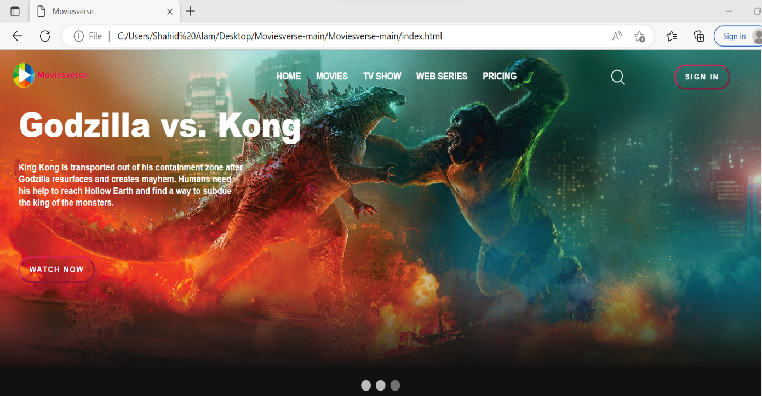

* **KNOWING THE WEBSITE:**

This is the first page and look of the website when opened. This section explains the functionality of various tabs, buttons, and options present on the website. This first page also gave the user a whole new experience in the world of OTT and Streaming. The format of the website is very simple that will definitely make the website very interesting. Each and every tab is explained here in full detail in order to make the functioning more efficient and user-friendly.

THE MAIN BAR:

The main bar is present at the top side of the first webpage. This section is responsible for creating and providing more creative and user-friendly access to the website. The can user browse almost all the options listed in the features of the website.



This is the main bar of the website. It has 6 different, unique and interesting icons including the options such as Home, Movies, TV shows, Web Series, Pricing , Search and Sign In. This will make the website more unique and user catchy. This also helps the users to engage with our website and will definitely give them a whole new experience.

HOME ICON:

By using the Home icon, user can return back to the Home page from the other tabs of the website. In the Home page there the user will again see the original page of the website and then proceed to other tabs from there like to the Package section, Destination section, and Contacts and others as per the user choice. User ca also proceed to special offer section from the home page only.

MOVIES:

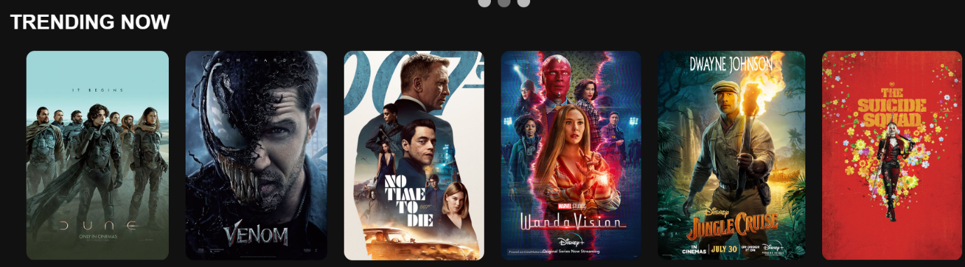

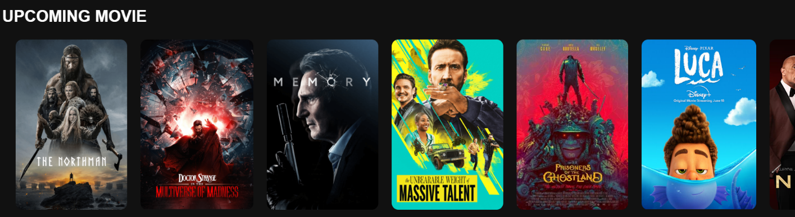

Our Movie section provides to users to choose from a variety of options and helps them to patiently surf without getting bored. User could find their favorite movies in this section. Users can directly reach Movies, web Series section from the main bar. In addition we have categorized the site with different streaming options for our dear users which they can enjoy with their friends and family. This offer is for a limited time only. The photos attached in this section will gave the users a brief idea about the different Categories of Movies .

**SIGN IN :**

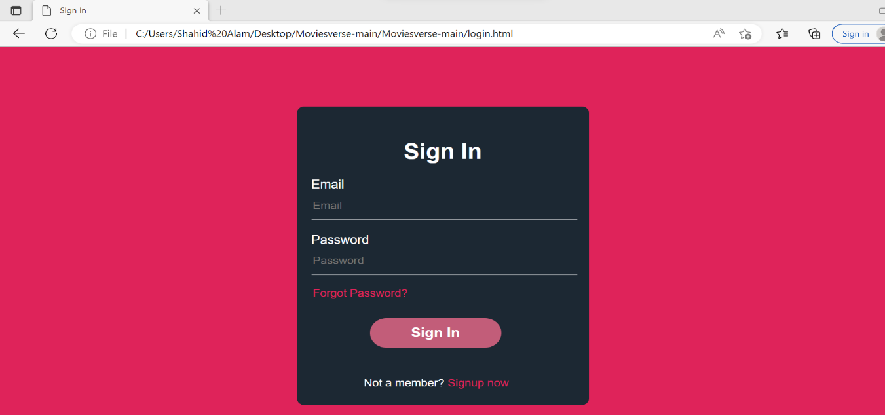

After clicking on the Sign in page in the home tab user will be redirected to sign in page.

From there user could login to their existing account and enjoy the streaming services.

If user don’t have an existing account then user could also make a new account through Sign up now.

**SIGN UP :**

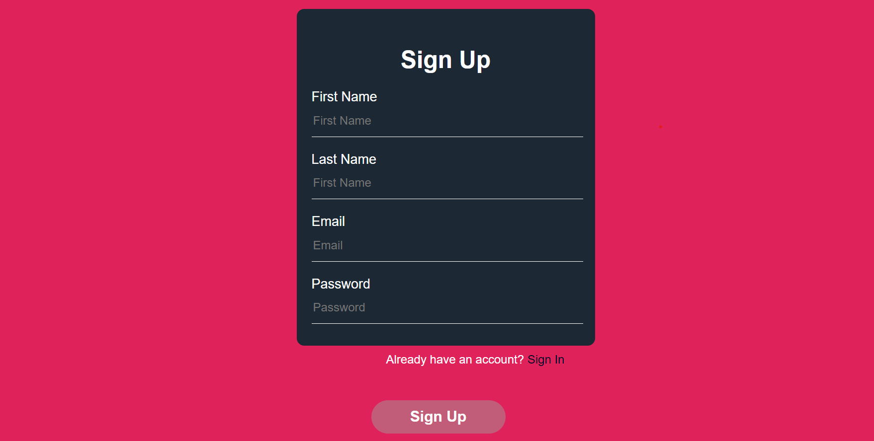

If user isn’t registered in the website then user could register through Sign up page.

**PRICING :**

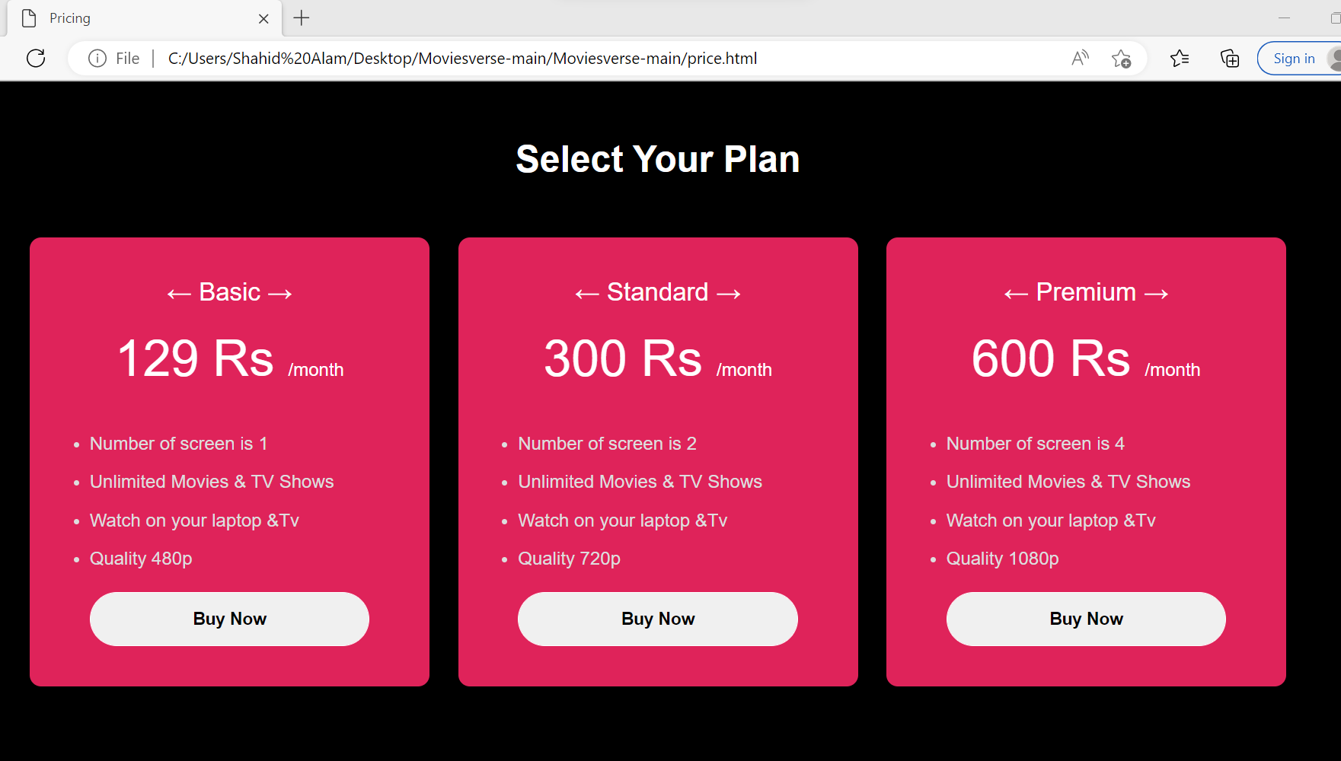

In pricing page user could select any available plan and purchase it by clicking on Buy now button and get the benefits according to that plan.

COPYRIGHT AND CONTACT:



**TECHNOLOGY USED:**

Three designing languages are used in building this website namely HTML and CSS. We’ve slightly used JavaScript also. This webpage can be opened with any browser such as Chrome, Firefox, Internet Explorer etc.

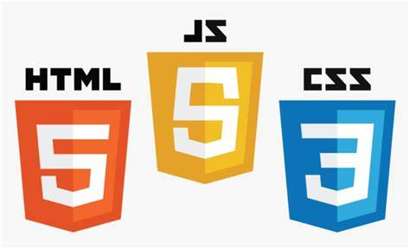

**MERITS OF THE PROJECT:**

* This project gave us a clear overview about HTML and CSS and made us understand it in a practical and descriptive manner.
* This project gave us a good lesson in understanding the working and functionality of any professional website and it made us aware of the demands, needs, of the public of the current generation.
* This project helped us with a lot of information about cascading style sheet and HTML. It also help us to have a slight idea about javascript.